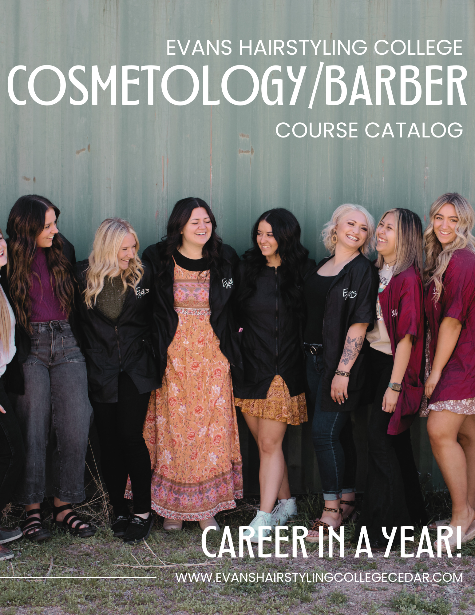



CEDAR CITY
Established 1974

169 North 100 West
Cedar City, Utah 84720

(435) 586-4486
evanscedar@gmail.com

www.evanshairstylingcollegecedar.com

Evans Hairstyling College is an Accredited Institution.
National Accrediting Commission of Career Arts and Sciences
3015 Colvin St.
Alexandria, VA 22314
(703) 600-7600

Evans Hairstyling College is licensed by the State of Utah.
Utah Division of Professional Licensing
160 East 300 South
Salt Lake City, UT 84114
(801) 530-6628

TABLE OF CONTENTS

School Objective or Mission Statement 2
Admission Procedures and Requirements 2
School Building 2
Admission Procedures and Requirements 2
Location 2
Length of Course and Graduation Requirements 3
School Term, Hours, and Subjects 3
Attendance Policy 4
Rights of Privacy 4
Grading Scale 4
Graduation Requirements 5
Employment Assistance 6
Tuition and Fees 6
Refund Policy 7
Scholarship Qualifications 7
Withdrawal and Termination Policy 8
Transfer Policy 8
Refund Schedule 8
Reentry Policy 9
Staff and Faculty 9

Mission Statement
At Evans Hairstyling College, our goal is to equip students with the knowledge, confidence, practical experience, and skills necessary to succeed in the beauty industry and secure employment after graduation.

About Us
Our campus is conveniently located just three blocks from Southern Utah University, right in the heart of town.

Spanning over 8,500 square feet, our facility includes a clinical area, classrooms, breakroom, pedicure room, facial room, eyelash room, wax room, mannequin workstations, and ample parking. The school is designed to accommodate up to 53 students, each with their own personal workstation and locker for storage.
We serve a diverse clientele of all ages, providing students with extensive hands-on training to prepare them for successful careers in cosmetology.

Our school is equipped with the latest computer systems for training and education. Our instructors are experienced hairstylists who continue to practice cosmetology outside of the school and stay up to date with the latest trends. They are also required to attend ongoing education to stay informed about new techniques and services.

Admission Requirements
Anyone who is focused on a career in Cosmetology and wants to pursue their education in this field is welcome to enroll at Evans. To join the Cosmetology/Barber program, the following requirements must be met:
- Provide a copy of a current government-issued photo ID
- Submit proof of secondary education, such as a high school diploma, GED certificate, an official transcript showing high school completion, or a state certification of home-school completion
- Pay a $100 application fee (this applies to transfer students and those reentering the program).
(A full refund is available if the enrollment is canceled in writing at least 30 days prior to the start of classes.)
For students submitting a foreign high school diploma, the school will assist in obtaining an English translation of the document, along with confirmation from an external agency that the education received is equivalent to a U.S. high school diploma.

On the first day of school, students must bring a three-ring binder, pen or pencil, a signed enrollment agreement, entrance fees, all required documentation, and a recent photograph.

EVANS is committed to providing equal opportunities and does not discriminate in its employment, admission, instruction, or graduation policies based on sex, age, race, color, religion, or ethnic origin. Additionally, Evans does not recruit students who are already enrolled or admitted to another school offering similar programs of study. (Please note: Evans does not participate in the Ability-To-Benefit program.)

High School Program
Evans Hairstyling College has partnered with the Iron County School District to offer high school seniors, who are working towards their high school diploma, the opportunity to enroll in our cosmetology program. Students enrolled in the high school program must provide proof of their high school diploma or GED by the end of the school year. To enroll, high school students must submit a Cosmetology Application form, provided by the Iron County School District, before the first day of class.
All high school students are required to start in the June class before their senior year to ensure they are present for the essential foundational classes taught at the beginning of the Cosmetology course.

Length of Course
Evans Hairstyling College offers a 1,600-hour program that can be completed within 12 months. Students have the option to complete up to 32 hours per week. Any hours not completed within the contracted graduation period will be made up at the end of the year.

Course Start Dates
Classes start the 2nd Tuesday of January, June, and September.

The school year is divided into 4 quarters: fall, winter, spring, and summer.

Evans will take a day off for most major holidays including New Years, President’s Day, Easter, Memorial Day, 4th and 24th of July, Labor Day, Thanksgiving, and Christmas.

Regular School Hours
Tuesday: 12:00 p.m. – 5:00 p.m.
Wednesday: 9:00 a.m. – 5:00 p.m.
Thursday: 9:00 a.m. – 5:00 p.m.
Friday: 9:00 a.m. – 5:00 p.m.
Saturday: 8:45 a.m. – 3:00 p.m.
Summer Hours
Tuesday: 9:00 a.m. – 5:00 p.m.
Wednesday: 9:00 a.m. – 5:00 p.m.
Thursday: 9:00 a.m. – 5:00 p.m.
Friday: 9:00 a.m. – 5:00 p.m.
Saturday: 8:45 a.m. – 1:00 p.m.

Cosmetology/Barber Program Outline
The Cosmetology/Barber Program (offered exclusively in English) is designed to equip students with the foundational skills, safety awareness, professional work habits, business knowledge, and positive attitudes necessary for obtaining licensure and succeeding in entry-level positions within Cosmetology or related fields.
The curriculum follows a structured sequence of learning steps, focusing on the specific tasks required for state board preparation, graduation, and job readiness. The program uses clinic equipment, tools, and products similar to those found in the industry. Students receive instruction that emphasizes practical, creative, and career-oriented activities. The program is delivered through detailed lesson plans employing various teaching methods, including interactive lectures, demonstrations, cooperative learning, student participation, and hands-on training with clients. Additional learning tools such as audio-visual aids, guest speakers, projects, and activities are incorporated throughout the program.

Grading Procedures
Practical skills are assessed based on textbook guidelines and the practical skills evaluation criteria established by the school. Students must maintain a minimum written grade average of 70% and make up any missed tests or incomplete assignments. The following grading scale applies:
- (A) 90 - 100 (5) EXCELLENT – Great work
- (B) 80 - 89 (4) GOOD – Improving
- (C) 70 - 79 (3) FAIR – Needs improvement
- (D) 65 – 69 (2) POOR – Unacceptable, redo (Minimum passing grade)
- (F) 0 – 64 (1) Unsatisfactory

Grades are assessed in four areas:
- Theory tests and assignments
- Clinical performance (clients, manikins, and peer work)
- School attendance
- Personal conduct

If a student fails a quarter or does not meet the minimum standards, they will have the opportunity to complete makeup work to raise their grade to the minimum required level or higher. This process will help them fulfill the program's requirements and successfully graduate.

Attendance Policy
Students are expected to attend school during regular operational hours, except when the school is closed for holidays or scheduled days off requested by the student.
School begins at 9:00 a.m., and students arriving after this time will be marked as tardy. Tardiness negatively impacts the student's scholarship grade. If a student is unable to attend due to illness or an emergency, the student or a responsible person must notify the school before 9:00 a.m. on that day to receive an excused absence or tardy. Failure to notify the school will result in an unexcused absence, which will also negatively affect the student's scholarship grade.
If a student falls behind in hours due to absences or tardiness, they will be required to make up the missed hours at the end of the year. (Additional tuition fees may apply if the student’s schooling extends beyond the contracted graduation date.)

Rights of Privacy
The Family Educational Rights and Privacy Act (FERPA) provides students with specific rights regarding their education records. These rights include:
- The right to inspect and review education records
Students may request to inspect their education records within 45 days of the school receiving the request. To do so, students must submit a written request to the registrar, dean, head of the academic department, or another appropriate official, identifying the records they wish to review. The school will arrange access and notify the student of when and where they can inspect the records. If the records are not maintained by the official the request was submitted to, the student will be directed to the correct official.
- The right to request an amendment of education records
If a student believes their education records are inaccurate, misleading, or violate their privacy rights under FERPA, they can request an amendment. Students should submit a written request to the school official responsible for the record, clearly identifying the part of the record they want amended and explaining why. If the school refuses to amend the record, it will notify the student in writing and inform them of their right to a hearing regarding the request. Further information about the hearing process will be provided.
- The right to provide written consent before disclosures
Students have the right to provide written consent before the school discloses personally identifiable information from their education records, except where FERPA allows disclosures without consent. The school may disclose records without prior written consent under the FERPA exception for disclosures to school officials with legitimate educational interests. School officials include those employed by the school in various positions such as administrative, academic, supervisory, or support staff, as well as contracted agents (e.g., attorneys, auditors). A school official has a legitimate educational interest if they need to review an education record to fulfill their professional duties.
- The right to file a complaint with the U.S. Department of Education
Students can file a complaint with the U.S. Department of Education if they believe the school has failed to comply with FERPA requirements. The contact information for the Family Policy Compliance Office is:
Family Policy Compliance Office
U.S. Department of Education
400 Maryland Ave. SW
Washington, DC 20202-5901
For further information on FERPA, HIPAA, recordkeeping, and related topics, please refer to Volume 2 of the current SFA Handbook and the chapter on recordkeeping. Additionally, institutions may include directory information public notice as part of their annual notification under FERPA, as required by regulation 99.37.

Graduation Requirements
To graduate, students must maintain a grade point average of 70% or higher, complete 1,600 hours within a minimum of 12 months but before the contract end date, and fulfill all practical assignments. Upon meeting these requirements, the student will be awarded a Certificate of Completion.Physical Demands
Students will be required to stand for extended periods, which can lead to fatigue.
Bending over shampoo bowls that are positioned too low may result in back strain.
The use of tools such as shears, clippers, irons, and razors carries the potential for harm or injury to both the client and the operator.
The job also involves frequent lifting and bending.
Carpal Tunnel Syndrome is another potential risk associated with repetitive hand and wrist movements.

Safety Requirements
Safety requirements include the ability to read labels on chemical products, understanding chemical mixtures, correctly using blow dryers and curling irons, and properly handling cutting tools to ensure the safety of both the public and the student.
Students may be at risk of exposure to bloodborne pathogens, dermatitis, and skin conditions. Additionally, prolonged exposure to chemicals and strong odors (such as ammonia-based products) may lead to breathing issues and other respiratory disorders.

Employment Assistance
While the school does not guarantee employment, we are committed to assisting students in their job search. Our support includes writing letters of recommendation, helping students create resumes, posting job listings on bulletin boards, offering classes, providing instruction on professional appearance (such as hygiene and etiquette), and connecting students with salon owners.

Possible Occupations
Salon owner, hairstylist, platform artist, color and perm wave technician, nail technician, product salesperson, makeup artist, facial technician, and more.
Advisement is provided for job placement, academic progress, individual development, and career opportunities. Counseling is available quarterly or as needed.

Compensation Possibilities
A cosmetologist can earn income through three main compensation methods:
- Commission – The stylist earns 40% to 75% of the income generated from their services.
- Paid by the hour – This varies by location, but the average is typically around $6 per hour until the stylist earns enough to transition from an hourly wage to commission-based pay.
- Booth rental – The stylist rents a workspace in a salon. The rent can vary depending on the salon.
Income will fluctuate based on the number of days worked and the specific salon. On average, with tips included, the national income for a cosmetologist is approximately $18.50 per hour.

Tuition and Fees
- Tuition: $15,000
- Books and Student Kit: Included
- Possible Scholarship (See scholarship qualifications): $2,500
- Required First Day Registration Fee (Note: Government funding does not cover this fee): $2,500
- Application Fee: $100
Students have the option to make monthly payments. These payments are interest-free and are due between the 1st and 15th of each month. The minimum monthly payment is $583.00. Payments can be made via cash, check, or credit card, with a 6% transaction fee applied to credit card payments.
If a student exceeds their contracted graduation time, an additional fee of $4.00 per hour or $32.00 per day will be charged until graduation.
Scholarships are available to first-time, full-time students who complete the full 1,600-hour course, with awards of $2,500. Scholarships are based on the student’s performance and achievements throughout the program and must be earned each quarter.
Financial Aid is available to eligible students. To apply for a Pell Grant, visit www.studentaid.gov and complete the application. Our school code is 017310. To apply for a student loan, go to the same website and complete the MPN (Master Promissory Note) and Entrance Counseling Form.Refund Policy
The refund policy is based on the number of scheduled hours or possible hours for the course. A fair and equitable settlement will apply for applicants who cancel their enrollment or students who withdraw. This policy applies to all terminations, regardless of the reason, including student decision, course or program cancellation, or school closure. Any money owed to the applicant or student will be refunded within 45 calendar days of the official cancellation or withdrawal. Official cancellation or withdrawal is determined by the earliest of the following dates:
- Applicant not accepted – If the applicant is not accepted by the school, they are entitled to a full refund of all monies paid.
- Cancellation within three business days – If a student (or legal guardian) cancels their enrollment in writing within three business days of signing the enrollment agreement, all monies collected by the school will be refunded, regardless of whether the student has started classes.
- Cancellation after three business days – If a student cancels their enrollment after three business days of signing the contract but before starting classes, they are entitled to a refund of all monies paid except the $100 application fee.
- Withdrawal notification – If a student notifies the school of their withdrawal in writing.
- Leave of absence – If a student on an approved leave of absence notifies the school they will not be returning, the withdrawal date will be the earlier of the expiration date of the leave or the date the student notifies the institution.
- Expulsion – If a student is expelled by the school (unofficial withdrawals are determined by monitoring attendance every 30 days).
- Cancellation or withdrawal dates – For cases in points 2, 3, 4, or 5, the cancellation or withdrawal date is determined by the postmark on the written notification or the date the notification is delivered to the school administrator or owner in person.
For students who begin classes but withdraw before completing the course (after the initial three-day period), the following tuition refund schedule applies. All refunds are based on the number of scheduled hours.
[Further tuition refund details would follow here based on the specific schedule.]
Refund Schedule
PERCENTAGE OF TIME POSSIBLE | HOURS POSSIBLE | PERCENT OF TUITION DUE | TUITION COST
0.1% TO 4.9% | 0000 TO 0078 | 20% | $3,000.00
5% TO 9.9% | 0078 TO 0158 | 30% | $4,500.00
10% TO 14.9% | 0159 TO 0238 | 40% | $6,000.00
15% TO 24.9% | 0239 TO 0398 | 50% | $6,750.00
25% TO 49.9% | 0399 TO 0798 | 70% | $10,500.00
50% AND OVER | 800 AND UP | 100% | $15,000.00
Refunds will be calculated based on the student's last date of attendance. Any money due to a student who withdraws will be refunded within 45 calendar days of determining the student's withdrawal, whether official or unofficial. In cases of disabling illness or injury, death in the student's immediate family, or other documented mitigating circumstances, a fair and reasonable refund settlement will be provided.
If the school permanently closes or ceases to offer instruction after a student has enrolled and instruction has begun, the school will offer a pro-rata refund of tuition or provide course completion through a pre-arranged teach-out agreement with another institution.
If the program is canceled after the student has enrolled but before instruction begins, the school will either provide a full refund or offer course completion. If the course is canceled after instruction has begun, the school will provide a pro-rata refund for all students transferring to another school based on the hours accepted by the receiving institution, provide course completion, participate in a Teach-Out Agreement, or offer a full refund of all monies paid.
This refund policy applies to all tuition and fees charged in the enrollment agreement.

Withdrawal and Termination Policy
If a student withdraws or is terminated before completing the required 1,600 hours of training, they will forfeit the $2,500 scholarship. Students will be charged according to the refund scale listed in this catalog for any unpaid tuition. If a student withdraws and has outstanding tuition fees or other charges, the hours accumulated will remain with the school until all balances are paid.
Students may be withdrawn or terminated for the following reasons:
- Transferring to another school
- A grade point average of less than 70%
- Not attending for 30 days from the last day of physical attendance
- Not returning from a leave of absence
- Not following school procedures

Transfers
Evans accepts transfer students from other cosmetology programs (if openings are available) with the appropriate documentation, such as transcripts, from the previous institution. If the student meets all competency requirements, their hours will be accepted. An evaluation will be conducted after orientation to determine the number of transfer hours accepted. The charge for transfer students will be per contract hour.

Reentry
Students who withdraw or are terminated may re-enter the program if their tuition balance is up to date. They will enter under the same policies as transfer students and will follow all transfer rules and policies. Re-admittance will be allowed only after an evaluation of the student's commitment to the program.

Staff and Faculty

Administrator and Owners
Evans Hairstyling College of Cedar City, Inc ________________________________

President- Derk M. Evans
Secretary- Kori L. Evans
Manager- Ashley Brown

Financial Aid Directors
Derk M. Evans
Ashley Brown

Instructors
Derk M. Evans
Ashley Brown
Madison Holyoak
RoseAnn Campbell
Brittany Whicker

Catalog updated 2025

